**Lab 3 OSG202**

**Tên: Nguyễn Mạnh Bảo Tín**

**MSSV: SE170134**

**Lớp: SE1710**

1. pstree command in Linux that shows the running processes as a tree which is a more convenient way to display the processes hierarchy and makes the output more visually appealing.

Syntax: pstree [options] [pid or username]

pstree -np

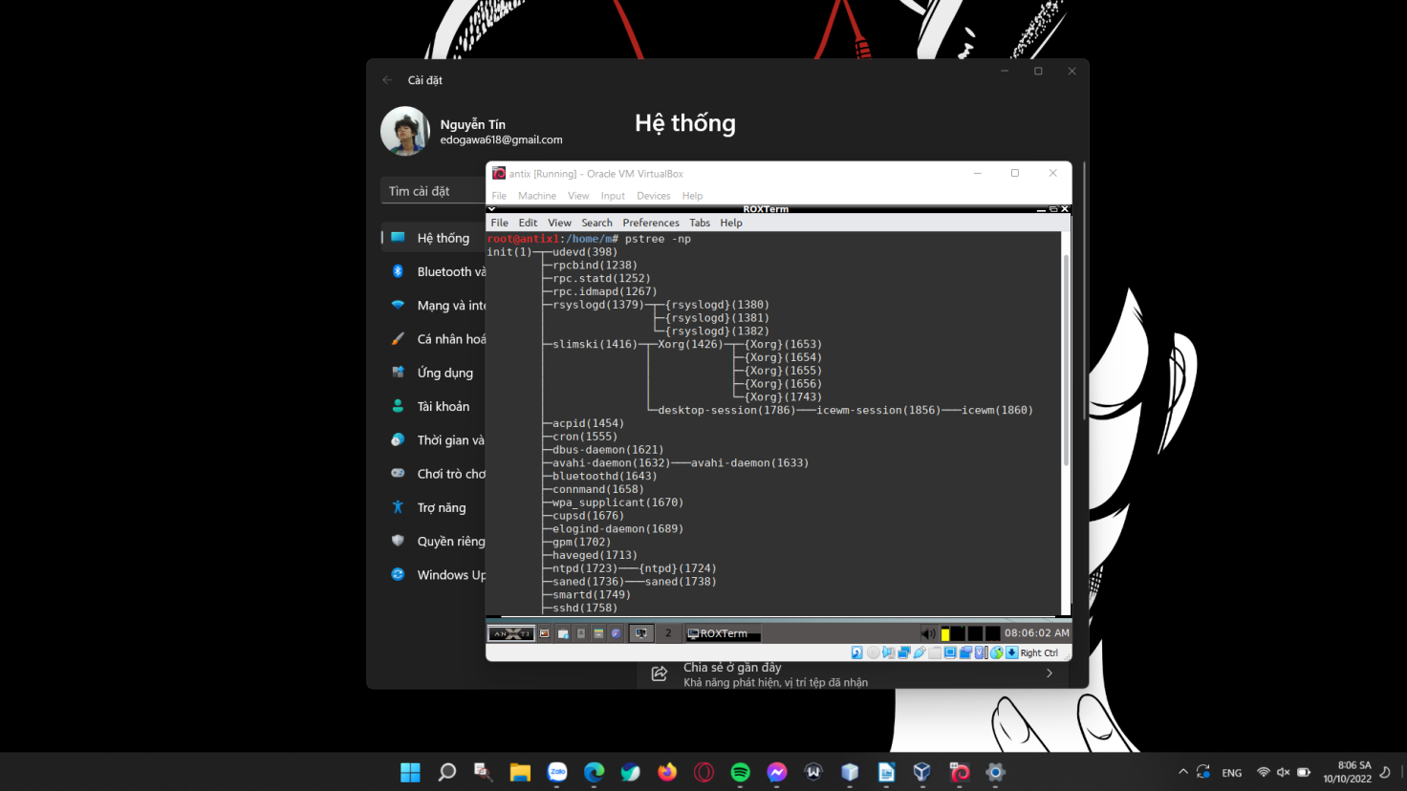

pstree -ls

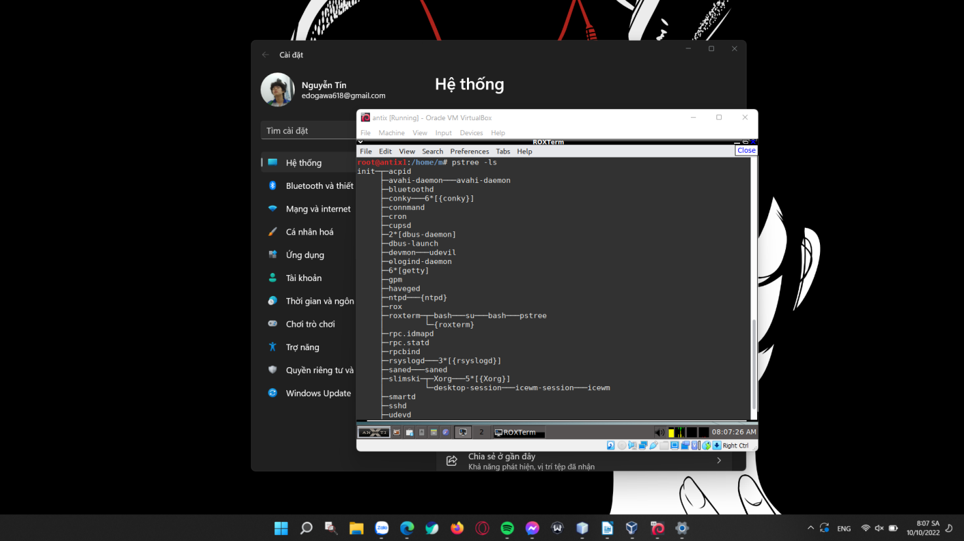

1. pkill is a command-line utility that sends signals to the processes of a running program based on given criteria. When invoked without any option, pkill sends the 15 (TERM) signal to the PIDs of all running programs that match with the given name. Which would kill all processes from that program.

Syntax: pkill [options]

pkill -help

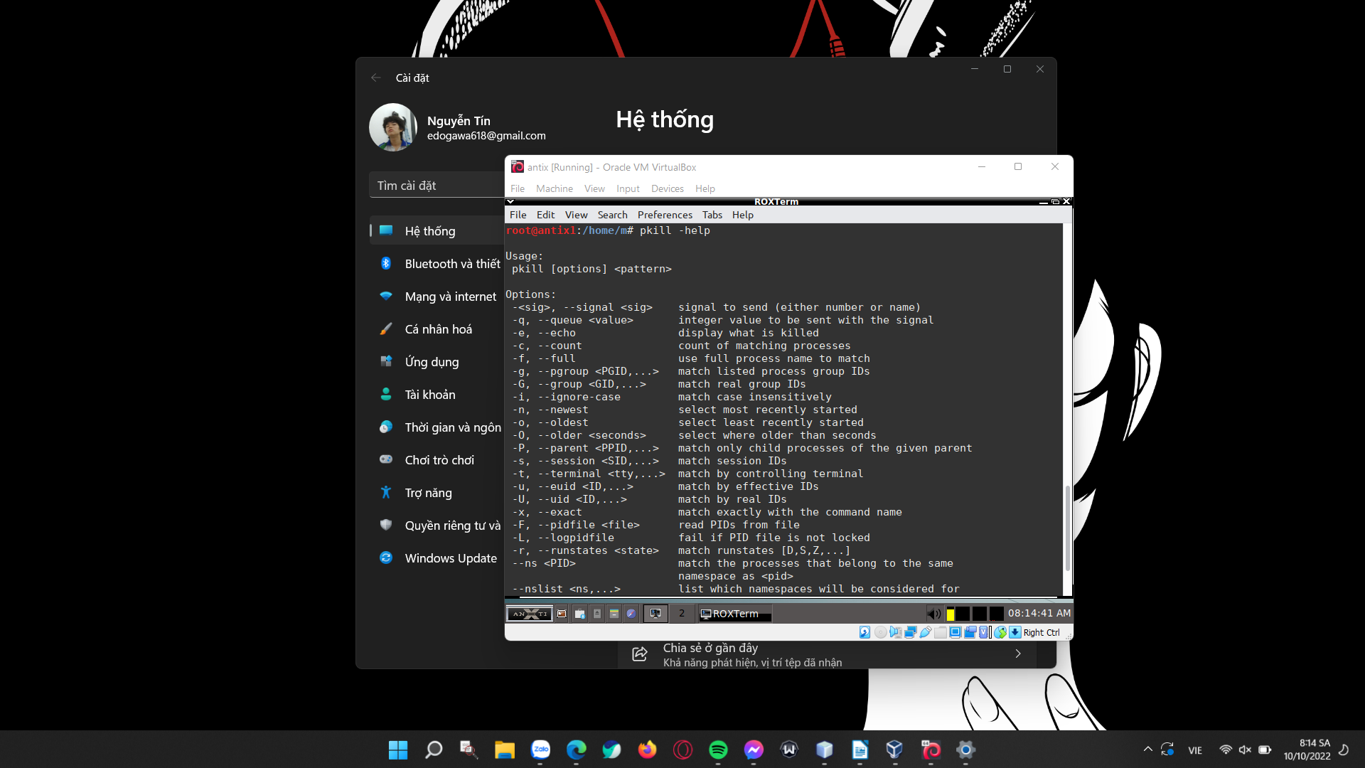

pkill -u <username>

Before executing line of command:

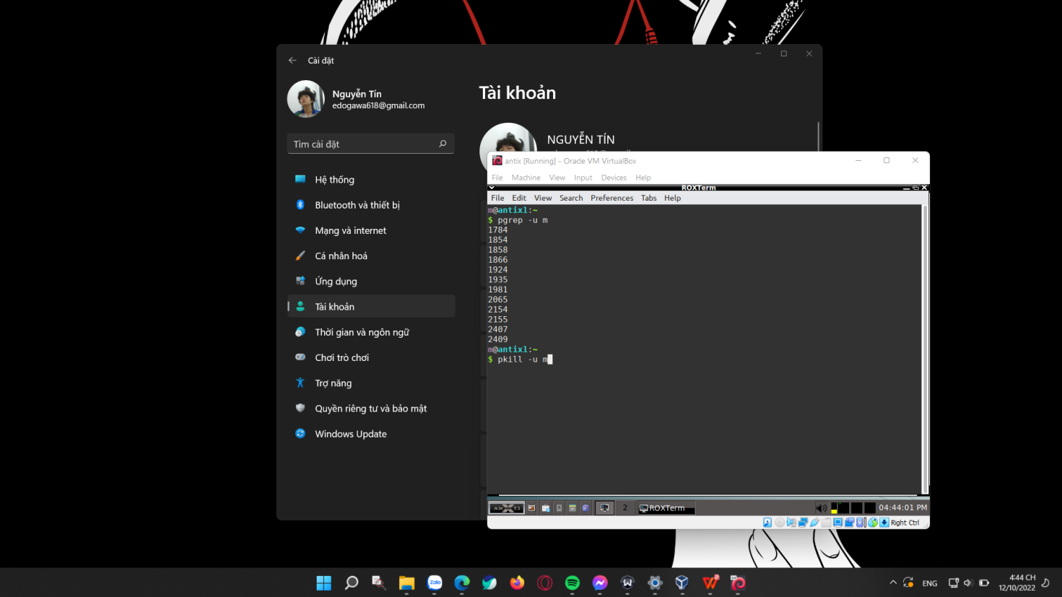

After executing line of command: pkill eventually ended all activities of the OS under the user “m”

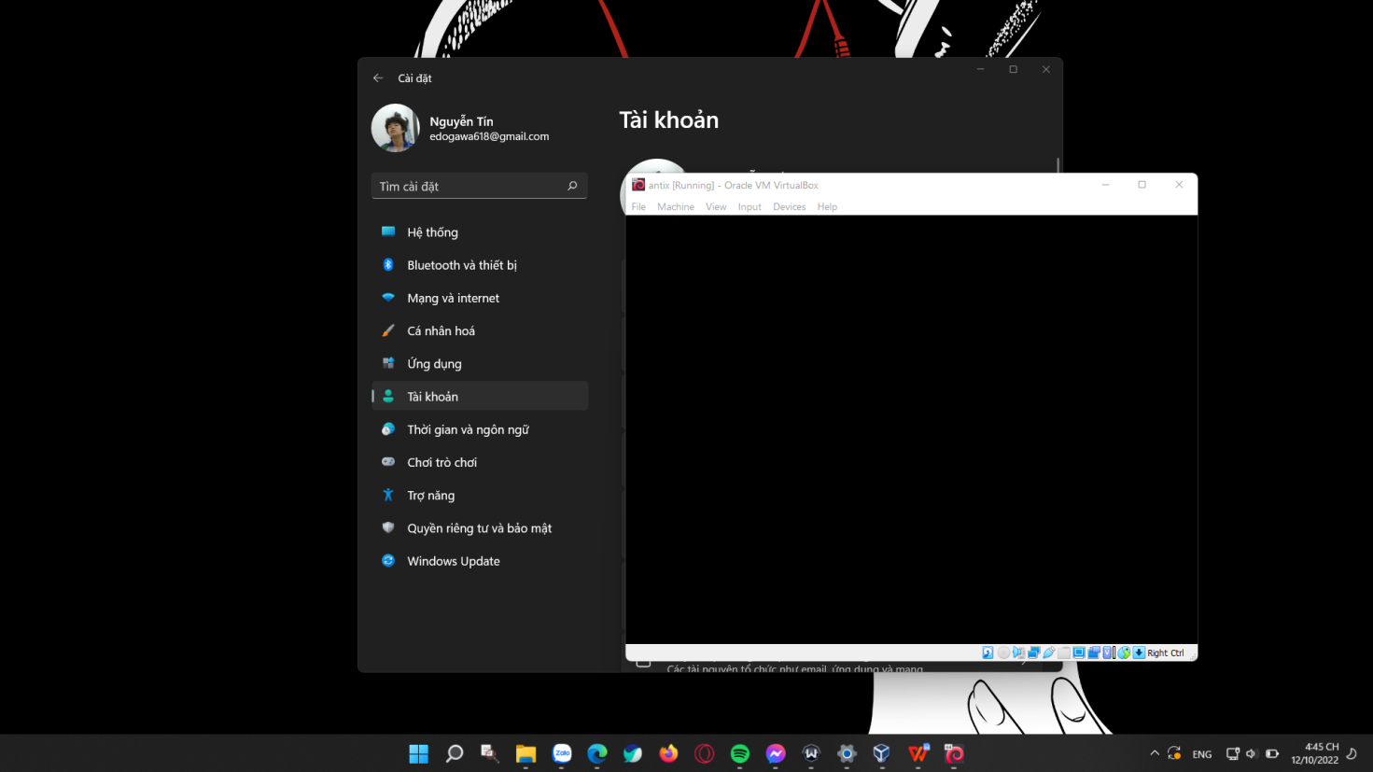

1. free command displays the total amount of free space available along with the amount of memory used and swap memory in the system, and also the buffers used by the kernel.

Syntax: free [OPTION]

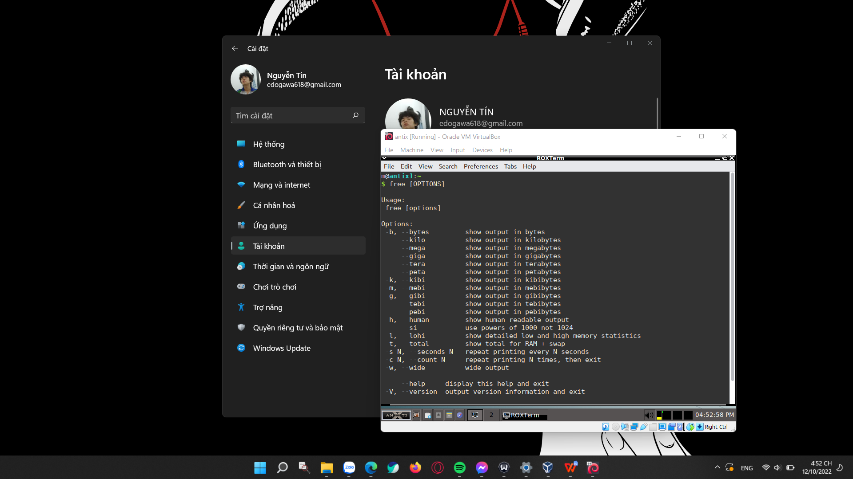

free --bytes:

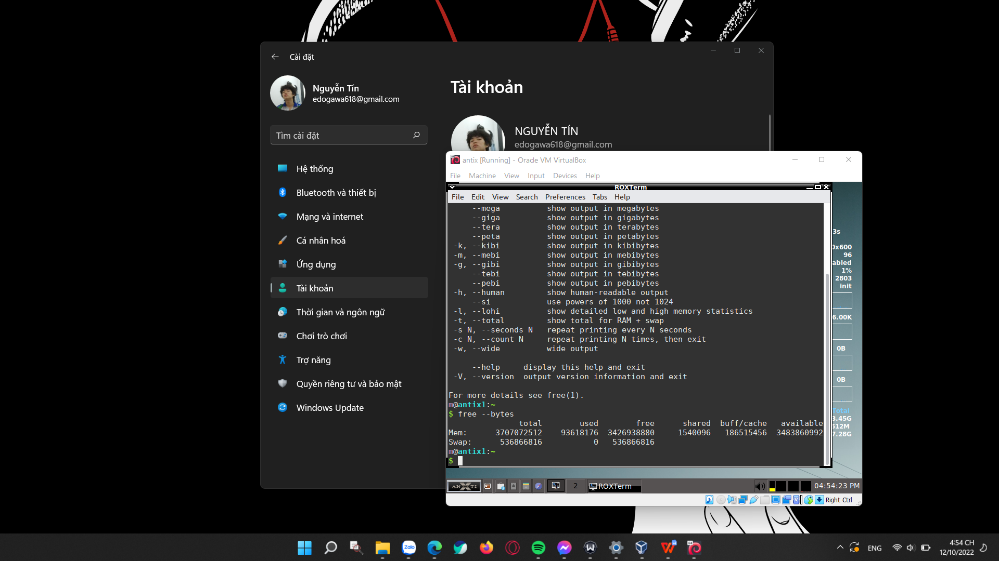

free --human and free --total

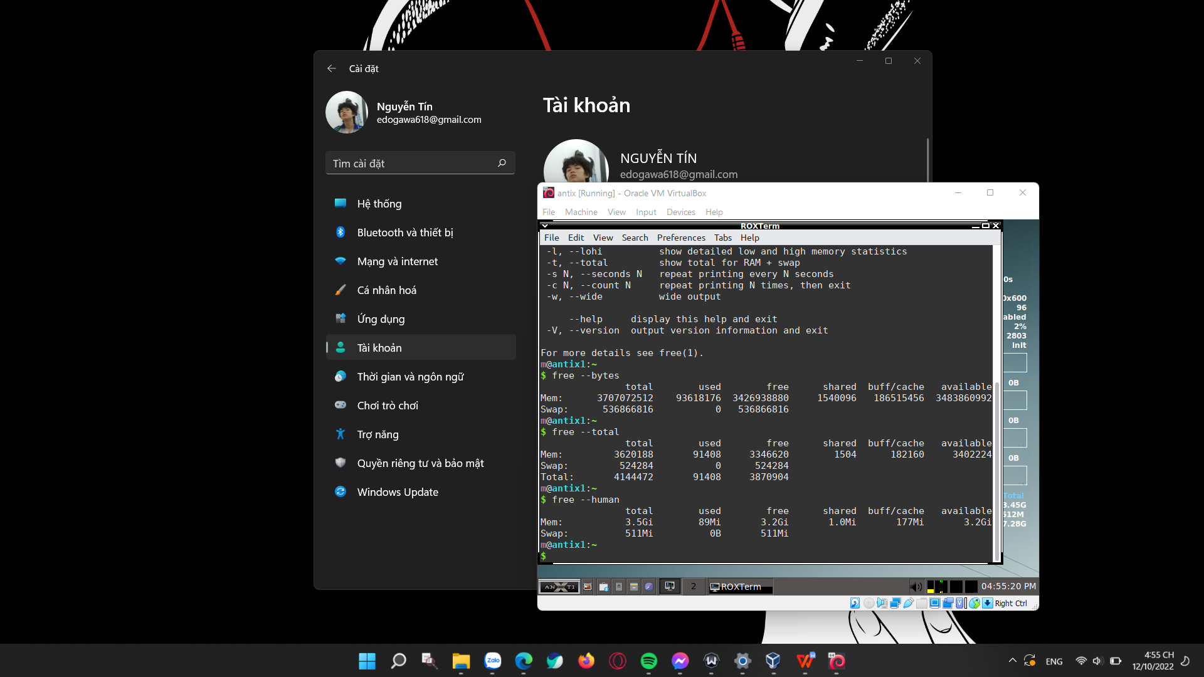

1. uptime is used to find out how long the system is active (running).

Syntax: uptime [OPTIONS]

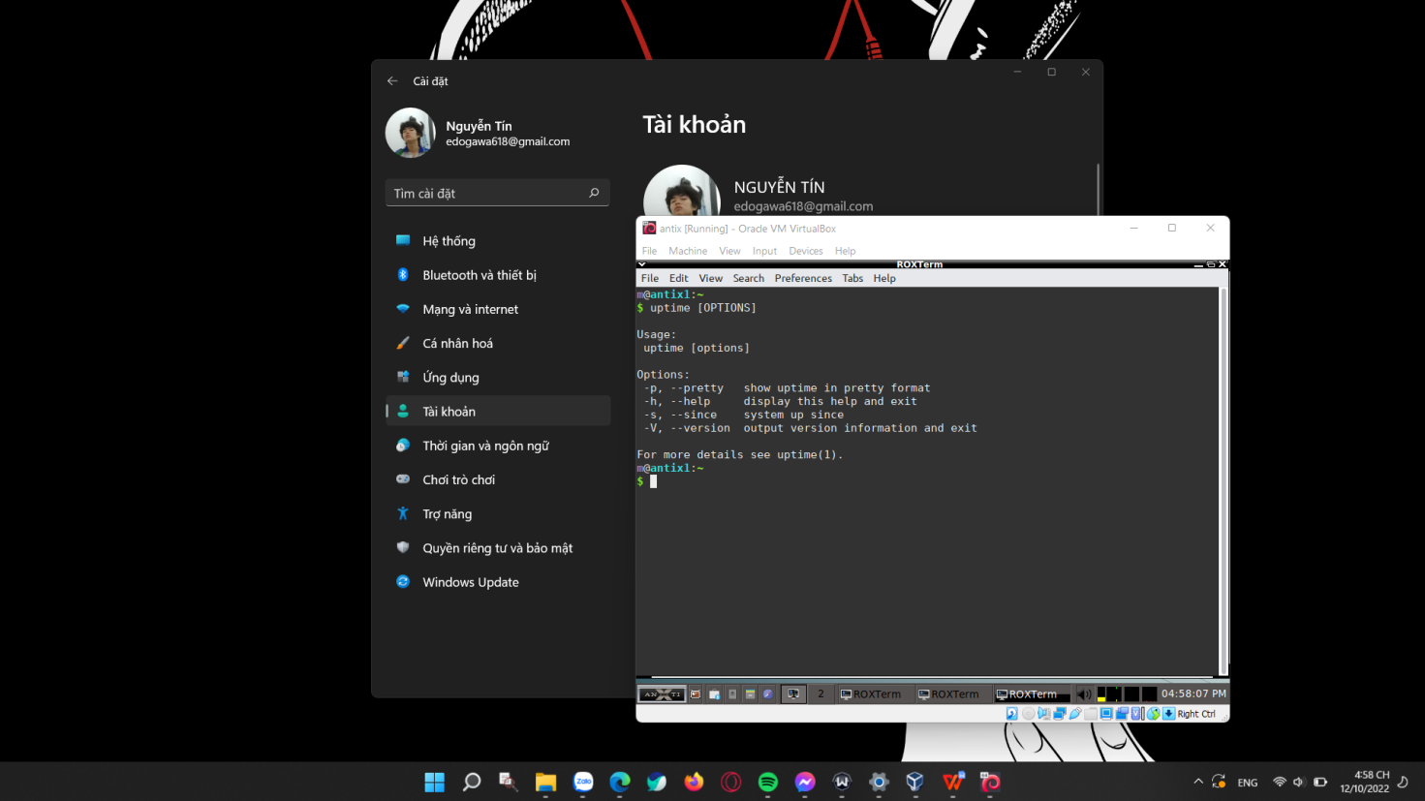

uptime --pretty

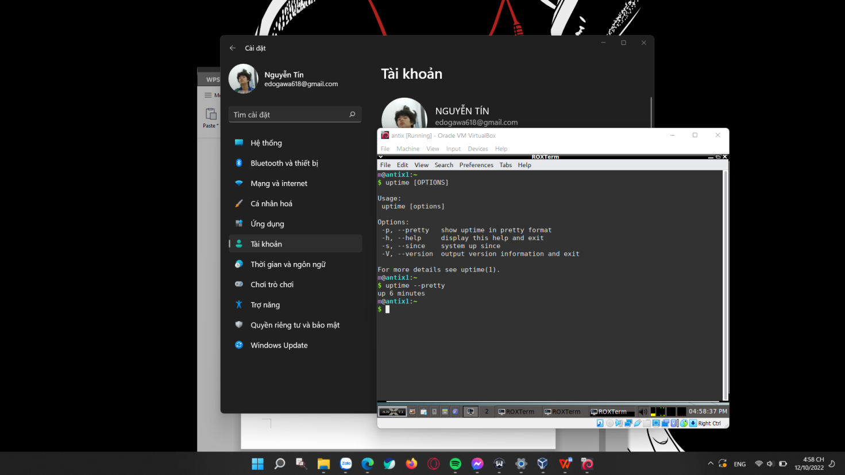

1. Capture the terminal screen using “pgrep -u root” command

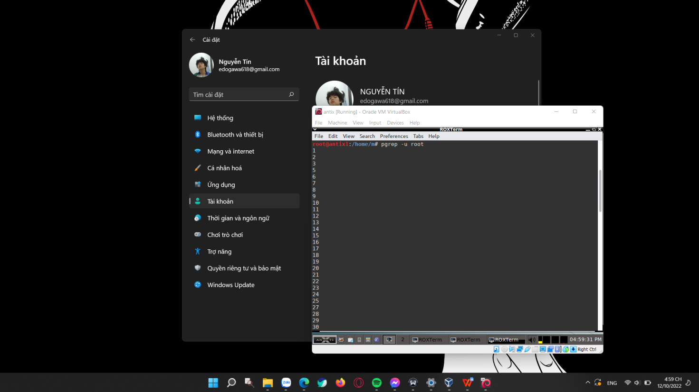

Explain the results: the command “prep -u root” shows all the processes being under the user “root” authority.

Opening task manager on Debian AntiX by commnad prompt, using the command “htop”.

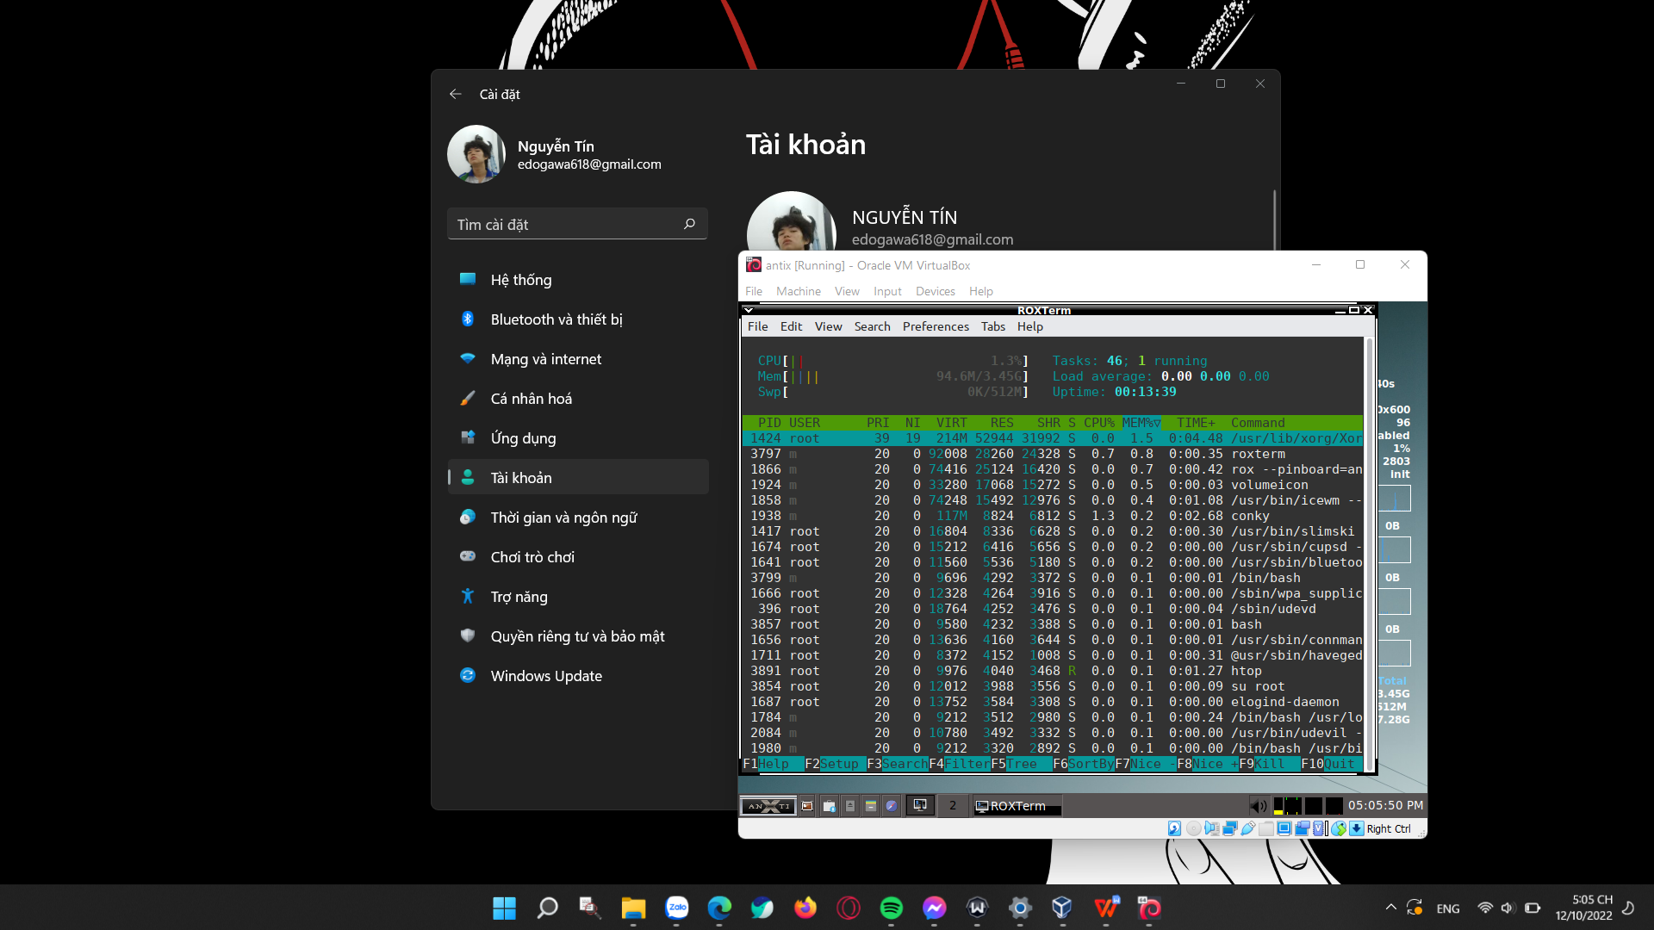

1. Opening GUI task manager on Debian AntiX:

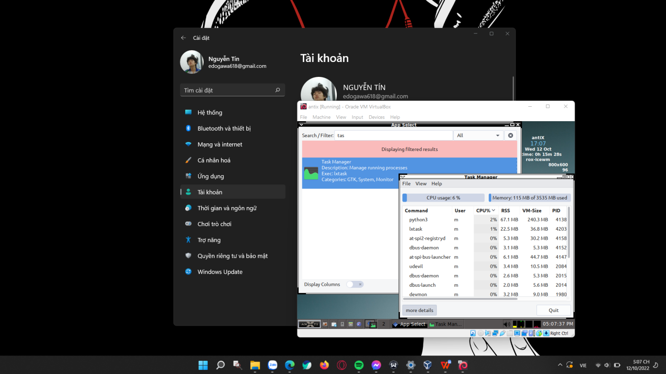

Open “Add/Remove Program” on Debian AntiX:

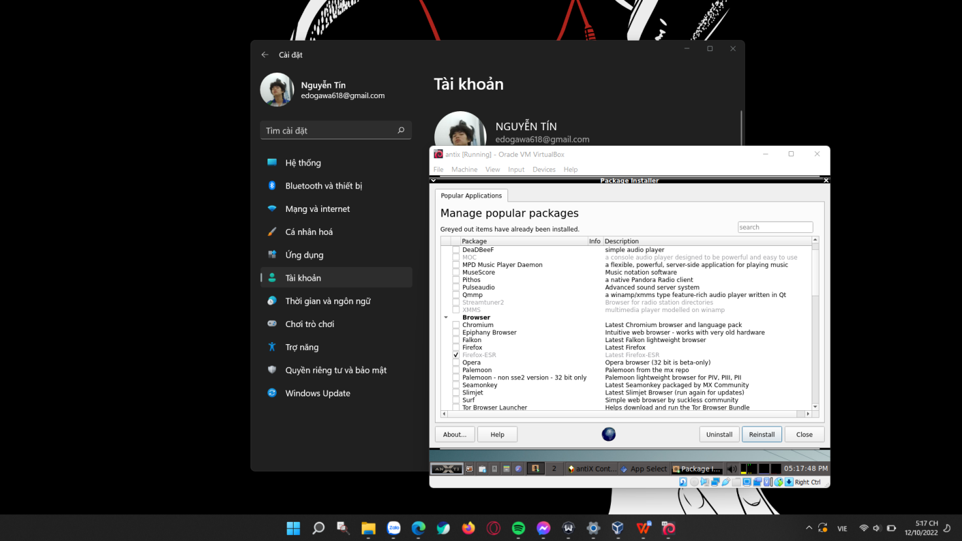

Relevant sources: [Linuxize](linuxize.com)